**Designing The ViewStocksFrame**

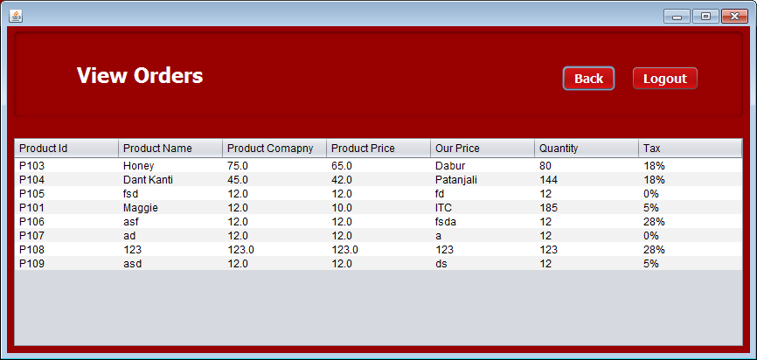

**STEPS TO BE DONE IN** **ViewStocksFrame**

In the **ViewStocksFrame** we need to do following steps:

1. Allow the user to **logout**
2. Handle the constructor to show all the Stocks available in the database.
3. Write code for the "**Back**" Button . When this button is clicked it should:

a**. Dispose the current frame and open the ManageStocksFrame.**